
A

PROJECT REPORT

ON

VARIATION IN THE VERTICAL PROFILE OF SELECTED SECONDARY RADIO-CLIMATIC PARAMETERS IN AKURE, NIGERIA

BY
OLASUPO MAYOWA EBENEZER
PHY/20/7261

SUBMITTED TO THE DEPARTMENT OF PHYSICS
SCHOOL OF PHYSICAL SCIENCE
FEDERAL UNIVERSITY OF TECHNOLOGY, AKURE ONDO STATE, NIGERIA.

IN PARTIAL FULFILMENT OF THE REQUIREMENTS FOR THE AWARD OF BACHELOR OF TECHNOLOGY (B.TECH ) DEGREE IN PHYSICS (ELECTRONICS).

SEPTEMBER, 2025

CERTIFICATION
This is to certify that the project upon which this report is based was carried out by OLASUPO MAYOWA EBENEZER PHY/20/7261 in the department of Physics, School of Physical Science, Federal University of Technology, Akure.

Olasupo Mayowa Ebenezer ...………………………….
(Student) Signature & Date

Prof M.O Ajewole …………………………...
(Supervisor) Signature & Date

DEDICATION
This project is dedicated to the Almighty God for his divine providence, kindness and mercy throughout the endeavor as well as in my academic pursuits in this magnificent fortress of learning.

ACKNOWLEDGEMENTS
I want to express my gratitude to the Almighty God for unwavering provision during this undertaking and for making the program a success. I also wish to thank my supervisor, Prof. M. O. Ajewole for his fatherly support and guidance in the course of this project.
My profound gratitude goes to Dr. A. G. Ashidi for his fatherly and constructive advice, teaching and provision of detailed technical guide, innovative approach, motivation and encouragement throughout the course of this project. And also Mr. Jimoh Opeyemi for his dedicated time and energy which he selflessly contributed into the success of this project. May the good lord bless them in all of their endeavor.
I also owe my admiration to the head of department, Prof. S. E. Falodun and all members of staff of the Department of Physics, School of Physical Sciences, Federal University of Technology, Akure, whose knowledge and academic assistance have been impacted on me throughout my program.
Lastly, I would like to appreciate my colleagues for the dedicated time and energy contributed in making data collection with UAVs a successful one.
ABSTRACT
This study investigates the vertical variation of secondary radio-climatic parameters - radio refractivity, refractivity gradient, and geo-climatic factor – for telecommunication applications in Akure, Nigeria. Data of temperature, pressure and relative humidity were collected at the ground surface and altitudes 25 m, 50 m, and 75 m, over 30 days and across six synoptic hours, for analysis. An Unmanned Aerial Vehicle System (UAVS) equipped with an Integrated Sensor Suite (ISS), was deployed for the high-resolution measurement of temperature, humidity, and pressure, which were then used to derive the secondary radio-climatic parameters. Results show that radio refractivity decreases steadily with altitude, with the highest values at the surface due to elevated humidity and pressure. The refractivity gradient revealed notable diurnal variability, with super-refraction and ducting conditions frequently occurring during early morning and evening hours, while sub-refraction dominated in the afternoon. The geo-climatic factor also indicated significant variability, suggesting a moderate to high risk of multipath fading in tropical environments such as Akure, Nigeria. These results demonstrate that reliance on standard atmospheric assumptions may underestimate anomalous propagation conditions in tropical climates. This study underscores the importance of incorporating UAV-based vertical profiling into routine atmospheric monitoring for improved accuracy in radio link design, radar operations, and spectrum management.

TABLE OF CONTENT

Title Page i
Certification ii
Dedication iii
Acknowledgments iv
Abstract v
Table of Content vi
List of Tables ix
List of Figures x
CHAPTER ONE – GENERAL INTRODUCTION
  - Background of the Study 1

  - Statement of the Problem 4

  - Research Questions 4
1.4 Aim and Objectives of the Study 5
1.5 Scope of the Study 5
CHAPERTER TWO – LITERATURE REVIEW
2.1 Introduction 6
2.2 Vertical Profiles of Radio-Climatic Parameters 6
2.2.1 The Vertical Variation of Radio-Refractivity 6
2.2.2 The Vertical Variation of Refractivity Gradient 7
2.2.3 The Vertical Variation of Geo-Climatic Factor (ΔN) 8
2.3 Integration of Vertical Profiles 9
2.4 Diurnal Variations of Secondary Radio-Climatic Parameters 10
2.5 The Radio Horizon 11
2.6 Effect of Refractivity on Electromagnetic Waves 13
2.7 Significance of Refractivity in Atmospheric Science 14
2.8 Refractivity and Its Measuring Techniques 14
2.9 UAVs for Atmospheric Refractivity Analysis 15
2.9.1 Application of UAVs in Atmospheric Refractivity Analysis 17
2.10 Research Gap 18
2.11 Theoretical Framework and Derivations 18
2.11.1 Water Vapor Pressure 18
2.11.2 Refractivity (N) 19
2.11.3 Refractive Index (n) 20
2.11.4 Refractivity Gradients 20
2.11.5 Geo-climatic Factor 20
CHAPTER THREE – METHODOLOGY
3.1 Site Description 22
3.2 Scope of Data 22
3.3 Instrumentation 22
3.4 Analytical Techniques 25
3.5 Analysis 28
3.6 Evaluation and Performance Metrics 28
CHAPTER FOUR – RESULTS AND DISCUSSION
4.1 Introduction 29
4.2 Radio-Refractivity Variation with Altitude 29
4.3 Diurnal Variation of Radio-Refractivity 29
4.4 Daily Variation of Radio-refractivity 30
4.5 Variation of Refractivity Gradient 35
4.5.1 Variation of Surface-Reference Refractivity Gradient with Synoptic Hours 35
4.5.2 Variation of Layer-by-Layer Refractivity Gradient with Synoptic Hours 36
4.5.3 Combined Refractivity Gradient (Surface-Referenced vs. Layer-by-Layer) 37
4.5.4 General Comparison and Discussion (Refractivity Gradient Versus Radio Refractivity with Altitude) 37
4.6 Variation of Geo-Climatic Factor with Altitude 39
CHAPTER FIVE – CONCLUSION AND RECOMMENDATIONS
5.1 Conclusion 43
5.2 Recommendations 44
REFERENCES 45

LIST OF TABLES
Table Title Page
3.1: Computed table for General Analysis 26
3.2: Pivoted Table for Analysis of Refractivity Gradient 27
4.1: Radio Refractivity Ranges and Propagation Effects 34
4.2: Refractivity Gradient Ranges and Interpretation 42
4.3: Geo-climatic Factor Ranges and Interpretation 42

LIST OF FIGURES
Figure Title Page
2.1: Effect of atmospheric refraction on the distance to the horizon 12
3.1: Preparation of UAV for Deployment 24
3.2: UAV in Deployment Mode Taking Atmospherically Data 24
4.1: Radio-Refractivity Variation with Altitude 32
4.2: Diurnal Variation of Radio-Refractivity 32
4.3: Daily Variation of Radio-refractivity 33
4.4(a): Variation of Surface-Referenced Refractivity Gradient with Synoptic Hours 40
4.4(b): Variation of Layer-by-Layer Refractivity Gradient with Synoptic Hours 40
4.4(c): Combined Refractivity Gradient (Surface-Referenced vs. Layer-by-Layer) 41
4.5: Variation of Geo-Climatic Factor with Altitude 41

CHAPTER ONE
GENERAL INTRODUCTION
1.1 Background of the Study
Radio climatic parameters are fundamental atmospheric variables that influence the propagation of electromagnetic waves, and by extension, the performance of communication and remote sensing systems. These parameters include temperature, pressure, humidity, and derived indices such as radio refractivity, refractivity gradient, effective Earth radius factor (k-factor), and the geo-climatic factor. The interaction of these variables with electromagnetic signals determines how radio waves bend, scatter, or attenuate as they travel through the atmosphere. Understanding these interactions is crucial for the planning, optimization, and operation of modern communication systems, including terrestrial microwave links, satellite communications, aviation radar, and emerging autonomous technologies (International Telecommunication Union. ITU-R P.453-13, 2019).
Among the secondary parameters, radio refractivity has been widely recognized as one of the most critical in defining the behavior of radio waves. Refractivity (N), which measures the deviation of the refractive index of air from unity, is primarily influenced by atmospheric pressure, temperature, and water vapor concentration (Hall & Barclay, 2012). Regions with high humidity and warm air often show elevated refractivity values, which enhance the bending of signals and sometimes produce abnormal propagation conditions such as ducting. On the other hand, drier conditions tend to lower refractivity and reduce coverage ranges (Oyewole et al., 2025). These variations are particularly significant in the tropics, where high temperatures and moisture fluctuations are common. As such, accurate refractivity modeling is indispensable for predicting link performance in regions such as Nigeria, where weather conditions vary significantly between wet and dry seasons.
Closely linked to refractivity is the refractivity gradient, which quantifies how refractivity changes with altitude. This parameter is vital in determining the curvature of radio wave paths relative to the Earth’s surface. Under standard conditions, refractivity decreases gradually with height, resulting in signals bending gently towards the Earth and extending the radio horizon (Fashade et al., 2023). However, abnormal gradients often occur due to atmospheric phenomena such as temperature inversions, stratified humidity layers, or rapid boundary layer changes. These abnormal gradients can lead to super-refraction, where signals bend excessively and travel longer distances than anticipated, or sub-refraction, where signals curve upward and limit coverage (Willoughby et al., 2017). In extreme cases, ducting may occur, trapping waves within certain atmospheric layers and enabling over-the-horizon transmission with minimal attenuation. Such phenomena can both enhance long-distance communications and interfere with radar operations, leading to false targets or missed detections. Consequently, understanding refractivity gradients is not only an academic exercise but also a practical necessity for defense, aviation, and telecommunication industries.
Another essential parameter is the effective Earth radius factor (k-factor), which accounts for the apparent change in the Earth’s curvature caused by atmospheric refraction. A standard value of k = 4/3 is commonly assumed in communication system design, but in reality, k-factor values fluctuate with changes in atmospheric conditions (Hall & Barclay, 2012). When the k-factor increases, communication systems may enjoy extended coverage, while decreases in k-factor can result in unexpected signal blockages or link degradation. These variations are particularly critical in designing microwave and radar systems in regions with complex weather dynamics. The International Telecommunication Union (ITU-R P.453-13, 2019) highlights that neglecting k-factor variations in system planning often leads to underestimating interference risks or coverage blackouts.
The geo-climatic factor (ΔN) is another derived parameter that reflects long-term refractivity variability near the Earth’s surface, driven by local climatic and geographical conditions. ΔN provides an index of how often and how severely refractivity gradients deviate from standard values in a given region (Lawal & Omotoso, 2023). For example, coastal regions and areas with frequent humidity stratification exhibit higher ΔN values, making them more prone to multipath fading, ducting, and other anomalous propagation effects (Willoughby et al., 2017). In contrast, arid inland regions tend to show smaller ΔN values, corresponding to more stable radio propagation conditions. This makes ΔN a crucial parameter in determining the long-term reliability of communication systems, particularly when assessing the feasibility of installing new telecommunication infrastructure.
In recent years, climate change has emerged as a global factor reshaping radio-climatic parameters. Changes in global temperatures alter atmospheric moisture distribution and vertical temperature profiles, which in turn affect refractivity and refractivity gradients. Li et al. (2019) note that such changes can modify the frequency and intensity of anomalous propagation events, posing challenges for systems that depend on stable communication environments. For developing regions like sub-Saharan Africa, where communication infrastructure is expanding rapidly, incorporating climate variability into propagation studies is becoming increasingly important to ensure system resilience.
Collecting reliable data on vertical profiles of refractivity and related parameters has traditionally relied on radiosondes, ground-based meteorological stations, or remote sensing systems. While effective, these methods are limited by high costs, coarse resolution, and sparse temporal coverage. The rise of Unmanned Aerial Vehicles (UAVs), commonly known as drones, has introduced a revolutionary approach to atmospheric monitoring. UAVs equipped with miniaturized sensors can measure temperature, pressure, and humidity at various altitudes, producing high-resolution vertical profiles of refractivity (Frew & Brown, 2020). Unlike radiosondes, which are often launched only twice a day, UAVs can be deployed flexibly, repeatedly, and at lower cost, offering near real-time atmospheric profiling. Zhou et al. (2022) emphasize that UAV-based measurements provide enhanced accuracy in modeling refractivity, particularly in detecting rapid changes in the atmospheric boundary layer that traditional methods often miss.
Beyond their technical capability, UAVs have broadened the scope of refractivity research applications. Real-time refractivity data collected using UAVs can be integrated into communication system planning, early warning systems, and radar calibration. For example, UAV data can help optimize microwave link alignments in urban areas, support early detection of ducting conditions for naval communication systems, or validate satellite-based atmospheric measurements. In addition, UAVs are invaluable in regions with limited infrastructure, where traditional radiosonde launches or ground-based monitoring stations may be infeasible. Their ability to traverse remote terrains, hover at fixed altitudes, or ascend through vertical profiles makes them an indispensable tool for modern atmospheric science.
Ultimately, the effect of refractivity on electromagnetic wave propagation underscores why this parameter remains central to communication engineering. Under typical conditions, refractivity decreases with altitude, causing radio waves to bend slightly toward the Earth, effectively extending the radio horizon. However, strong gradients from phenomena such as temperature inversions or moisture surges can cause super-refraction or ducting, alter propagation paths and lead to unexpected signal behavior (Smith, 2018). Sub-refraction, in contrast, reduces coverage and weakens communication reliability. These effects are magnified at higher frequencies, such as those used in microwave and satellite communication systems, which are especially sensitive to refractivity gradients (ITU-R P.453-14, 2021).
In summary, the study of vertical profiles of secondary radio-climatic parameters including refractivity, refractivity gradient, k-factor, and geo-climatic factor is indispensable for understanding how electromagnetic waves propagate in the atmosphere. The integration of UAVs into this field provides unprecedented opportunities for high-resolution, real-time monitoring, offering significant benefits for communication, radar, navigation, and climate studies. In regions such as Nigeria, where communication infrastructure and atmospheric variability are both critical, such research is not only timely but also essential for advancing reliable and efficient radio communication systems.
1.2 Statement of the Problem
Despite the importance of secondary radio-climatic parameters, especially refractivity, limited studies have been conducted on their vertical distribution, particularly in relation to their spatial and temporal variability. This gap in knowledge poses a challenge in designing communication systems that can adapt to atmospheric changes. Moreover, the lack of localized data on refractivity profiles further complicates accurate modeling and forecasting, especially in under-researched regions.
1.3 Research Questions
This study aims to address the following research questions:
- how do secondary radio-climatic parameters such as radio refractivity, k-factor, geo-climatic factor vary with height in the lowest layers of the atmosphere?
- what are the implications of these variations on atmospheric refractivity and electromagnetic wave propagation?
- how can UAV-based measurements enhance the accuracy and resolution of vertical refractivity profiling?
1.4 Aim and Objectives of the Study
1.4.1 Aim
The aim of this study is to deploy UAV system for the measurement and investigation of the variation in the vertical profile and temporal distribution of secondary radio-climatic parameters.
1.4.2 Objectives
The specific objectives of this study are to:
- deploy UAV system for the measurement of high-resolution atmospheric data for the analysis of radio refractivity;
- examine the vertical profile of radio refractivity, refractivity gradient and geo-climatic factor;
- evaluate the temporal variation of the selected secondary radio-climatic parameters.
1.5 Scope of the Study
This study is dedicated to the investigation of secondary radio-climatic parameters, namely, refractivity, refractivity gradient, k-factor, and geo-climatic factor and their variation with altitude towards examining their vertical profiles, and assessing their implications for radio wave propagation within the atmospheric boundary layer.
Geographically, the study is confined to the Federal University of Technology, Akure (FUTA), Ondo State, Nigeria. The temporal scope of the study covers a 30 days observation period, capturing short-term and diurnal variations but not seasonal or long-term climatological trends. Similarly, measurements were restricted to four altitude levels (surface, 25 m, 50 m, and 75 m) and six synoptic hours (06:00, 09:00, 12:00, 15:00, and 18:00 local time).
Lastly, the study is theoretical and analytical in nature, relying solely on observational data and mathematical derivations.

CHAPTER TWO
LITERATURE REVIEW
2.1 Introduction
The study "Variation in the Vertical Profile of Some Secondary Radio-Climatic Parameters" examines how certain atmospheric conditions affect radio wave propagation, particularly in the troposphere. It focuses on how these conditions, which include parameters like radio-refractivity, refractivity gradient, k-factor, and geo-climatic factor, impact radio wave travel and their importance in communication systems. This research investigates how these parameters changes with height (vertical profile) and over different times of the day.
2.2 Vertical Profiles of Radio-Climatic Parameters
Recent studies describe vertical profiles as representations of how atmospheric parameters change with altitude above the Earth's surface. In atmospheric sciences, vertical profiles are widely used to show how meteorological and radio-climatic variables (such as temperature, humidity, and refractivity) vary with height; for example, Usman et al. (2024) analyzed vertical gradients of radio refractivity over several Nigerian cities, and Fashade et al. (2023) evaluated refractivity gradients and related parameters in different climatic zones, confirming that gradient magnitude and behavior change significantly with altitude.
In addition, Hall and Barclay. (2012) added that vertical profiles illustrate how refractivity, refractivity gradient, k-factor, and geo-climatic factor behave at different atmospheric levels. For example, the vertical profile of radio refractivity generally shows a steep decrease near the surface, where air is denser and more humid, followed by a gradual reduction with increasing altitude. Similarly, the vertical profile of refractivity gradient shows the rate of refractivity change with height, which can produce normal, super-refractive, or sub-refractive propagation conditions (Willoughby et al., 2017).
2.2.1 The Vertical Variation of Radio-Refractivity
According to Usman et al., (2024), Ogunjo and Adesiji (2020) atmospheric refractivity is known to decrease with altitude, primarily due to the vertical gradients of pressure, temperature, and humidity. The lower troposphere, particularly near the surface, exhibits the highest refractivity values because it contains a higher concentration of water vapor and denser air masses. As altitude increases, both air pressure and humidity decrease, resulting in a corresponding reduction in refractivity.
Adediji and Ajewole (2008), also reported that Several studies have documented that the refractivity gradient is steepest within the first few hundred meters above the ground, where rapid changes in temperature and moisture are most pronounced This vertical stratification is especially important in communication and radar systems, as it affects signal bending, ducting, and path loss.
Recent studies show that the rate of refractivity decrease with altitude depends heavily on local climatic conditions, diurnal cycles, and surface heating. For example, a study over Central and West Africa found that low-altitude refractivity gradients are weaker during midday due to solar heating, and much stronger during early morning and evening (Kaissassou. et al., 2021). Similarly, analysis of satellite-derived meteorological data across West Africa revealed that refractivity decreases exponentially with height and that seasonal and regional factors (coastal vs. desert) meaningfully alter the gradient magnitude (Abimbola et al., 2020).
More recently, Lewis et al. (2023) developed new methods using radio signal angle of arrival to retrieve vertical refractivity profiles and confirmed that both altitude decay rates and profile shape change between day and night. Integration of radiosonde and satellite or signal-based techniques remains important for capturing the full dynamics of the troposphere in those regions.
Overall, there is consensus that radio refractivity is central to radio meteorology, but debate exists regarding the reliability of existing measurement techniques. While radiosondes are widely used, Zhou et al. (2022) argue that UAV-based profiling offers superior resolution and adaptability. This study aligns with the view that UAVs provide a promising path for improving refractivity measurement.
2.2.2 The Vertical Variation of Refractivity Gradient
Recent studies describe the refractivity gradient as how refractivity changes with altitude, with standard atmospheric models often assuming a gradient around –39 N-units/km, which produces the typical downward bending of radio signals. For example, Akpootu et al. (2024) found a standard atmosphere gradient of –39 N-units/km in several locations in Nigeria. However, more extreme negative gradients (e.g. –75 N-units/km in Sokoto) are observed under temperature inversions and high moisture, leading to super-refraction. Conversely, gradients that are less negative (closer to zero) may produce sub-refraction, reduce coverage and cause signal attenuation. Sabiru et al. (2024).
Willoughby et al. (2017) noted that refractivity gradients are especially important in radar applications, where abnormal gradients can create radar holes or ghost targets. Similarly, ITU-R P.453-13 (2019) emphasized that gradient variations directly influence effective Earth radius calculations and long-distance communication planning.
2.2.3 The Vertical Variation of Geo-Climatic Factor (ΔN)
The geo-climatic factor, ΔN, represents the average refractivity gradient in the lowest kilometer of the atmosphere and is strongly influenced by local geography and climate (ITU-R P.453-13, 2019). According to Hall and Barclay (2012), ΔN is critical in determining long-term propagation conditions such as multipath fading probability.
Coastal regions, which experience frequent humidity fluctuations and temperature inversions, often record elevated geo-climatic factor (ΔN) values—this increases the likelihood of ducting and multipath interference. For example, a recent study over Ikeja, Lagos (Layioye, 2024) found that the average point refractivity gradient at 70 m is about −196 N-units/km, and geo-climatic factor was significantly high during wet months, confirming that coastal atmospheric conditions strongly favor signal bending and interference effects.
Owolabi et al. (2021) emphasized the importance of ΔN in spectrum management, noting that regional variations can significantly affect network reliability. Willoughby et al. (2017) further observed that failure to account for ΔN in link planning may result in significant signal degradation, especially in tropical regions where atmospheric variability is pronounced.
Literature highlights ΔN as a key parameter in long-term planning of communication systems. However, most studies use climatological averages that may not capture real-time variations. This review argues that UAV-based profiling can complement long-term averages by providing location-specific ΔN values for adaptive communication planning.

2.3 Integration of Vertical Profiles
Recent studies have reaffirmed that integrating vertical profiles of atmospheric parameters is essential for accurate modeling of electromagnetic wave propagation. For example, Statistics of Vertical Refractivity Gradient over Akure, Nigeria (Ogunjo & Adesiji, 2020) emphasizes that refractivity measured only at the surface fails to capture the variations with height that affect propagation, especially in the troposphere's lowest layers. Similarly, Wang et al. (2018) show that incorporating full vertical profiles improves predictions of beam bending in radar and communication systems. Thus, because atmospheric refractivity, temperature, and humidity vary significantly with altitude, using integrated vertical profiles yields a completer and more accurate picture than relying on surface-level data alone.
One of the most important applications of vertical profile integration is in refractivity modeling. By integrating refractivity data with height, it is possible to estimate the effective path of radio signals and predict conditions such as ducting, multipath fading, and signal attenuation (ITU-R P.453-13, 2019). Without this integration, models would fail to capture abnormal propagation effects that occur in specific atmospheric layers.
Similarly, Hall and Barclay. (2012) added that integrating refractivity gradients into models provides insight into the types of propagation regimes present in the atmosphere. For example, a strong negative gradient in the lower atmosphere may indicate super-refraction or ducting, while a weaker gradient suggests normal propagation. By combining multiple layers of gradient data, engineers and scientists can forecast radio link reliability more effectively.
The integration of k-factor vertical profiles is also essential. While the standard value of k = 1.33 is often assumed for convenience, real-world variations in the atmosphere cause deviations that significantly affect line-of-sight communication and radar horizon estimates (Turton et al., 1988). By incorporating altitude-dependent k-factors, system designers can correct for atmospheric bending and reduce errors in coverage planning.
For the geo-climatic factor (ΔN), integration ensures that both local and regional atmospheric influences are captured. Since ΔN values are strongly dependent on geographic location and seasonal cycles, integrated profiles provide a statistical representation of the atmosphere over time, which is crucial for the design of long-term and resilient communication systems (Willoughby et al., 2017).
Overall, Clifford et al., (2020). Supports that the integration of vertical profiles allows for a holistic assessment of radio wave propagation. This approach enhances the accuracy of predictive models, supports the optimization of wireless networks, and contributes to applications in radar, remote sensing, and satellite communications.
2.4 Diurnal Variations of Secondary Radio-Climatic Parameters
Stull, (2017) report that diurnal variations play a significant role in shaping the behavior of atmospheric parameters, particularly in the lower troposphere. Temperature, relative humidity, and refractivity exhibit distinct daily cycles influenced by solar radiation and surface heating. Typically, surface temperatures rise after sunrise, peak in the early afternoon, and decline after sunset. These changes result in fluctuations in atmospheric stability and influence the vertical distribution of moisture and refractive properties.
Holton and Hakim (2012) also emphasize that humidity generally increases during the night due to cooling and condensation near the surface and decreases during the day due to evaporation and warming. This cycle causes corresponding changes in refractivity, with higher values observed in the early morning and late evening hours. These fluctuations are essential in understanding the formation of inversion layers and radio ducting phenomena, which affect electromagnetic wave propagation.
Refractivity gradients are typically steeper during the early morning due to high moisture content and temperature inversions, which can lead to enhanced bending of radio signals. As surface heating intensifies during the day, vertical mixing reduces these gradients, altering signal propagation conditions. Holton and Hakim (2012)
Adediji A.T et al (2015) explains that understanding diurnal patterns helps in planning radio communication and remote sensing operations, particularly those relying on atmospheric stability and refractivity behavior throughout the day.

2.5 The Radio Horizon
Hall and Barclay. (2012) explains that the radio horizon represents the maximum distance over which a radio signal can be received when considering the bending of radio waves due to atmospheric refraction. It extends beyond the line-of-sight (LOS) horizon, which is limited only by Earth’s curvature. This effect occurs because the refractive index of the atmosphere decreases with height, causing radio signals to bend slightly toward the Earth’s surface.
As illustrated in Figure 2.1, the LOS horizon is the geometric limit of direct sight between an antenna at height h and the Earth’s surface. However, due to atmospheric refraction, the actual propagation path of the radio signal bends downward, creating an extended range known as the radio horizon. This bending effectively increases the Earth’s radius by a factor k, commonly approximated as 1.33, which lengthens the distance over which communication is possible (ITU-R P.453-13, 2019).
The importance of the radio horizon lies in its application to line-of-sight communication systems. For instance, microwave links, television broadcasting, and radar operations all rely on accurate predictions of the radio horizon to ensure reliable coverage. As shown in Figure 1, the refracted local horizontal ray demonstrates how bending extends communication paths beyond the purely geometric limit. This explains why signals can be received even after the LOS is blocked by Earth’s curvature. (ITU-R P.453-13, 2019).
In conclusion, the radio horizon is always greater than the LOS horizon because of atmospheric refraction. Incorporating vertical profiles of refractivity and k-factor into radio horizon calculations improves the accuracy of wireless communication system planning and reduces signal loss uncertainties (Parsons, 2000).

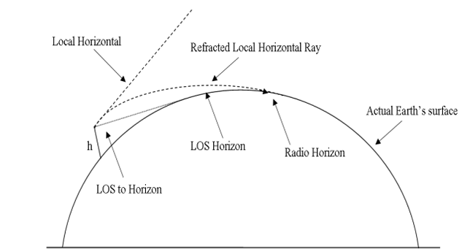
Figure 2.1: Effect of atmospheric refraction on the distance to the horizon. (ITU-R P.453-13, 2019).

2.6 Effect of Refractivity on Electromagnetic Waves
Atmospheric refractivity significantly influences the propagation of electromagnetic waves through the Earth's atmosphere. This interaction is crucial in radio communication, radar systems, and remote sensing operations. Refractivity alters the path of electromagnetic waves by bending them toward regions of higher refractive index, a phenomenon governed by Snell's Law. The gradient of refractivity with height determines whether a wave will bend gradually, sharply, or become trapped within certain atmospheric layers (ITU-R P.453-14, 2021).
Sabiru et al. (2024). further explain that under normal atmospheric conditions, refractivity decreases with altitude, causing EM waves to bend slightly toward the Earth. This phenomenon extends the radio horizon and is beneficial for long-distance terrestrial communication. However, when abnormal refractive gradients occur such as during temperature inversions or layers with abrupt humidity changes waves may experience super refraction or ducting. These conditions trap EM waves between atmospheric layers, enabling long-range propagation with minimal attenuation. Smith (2018) highlights that ducting is particularly advantageous for maritime communications and over-the-horizon radar systems.
In addition, Adediji and Ajewole (2008) explains that sub-refraction occurs when the refractivity gradient is weaker than normal, causing waves to bend away from the Earth. This reduces the effective communication range and can lead to increased signal loss, posing challenges for line-of-sight systems. Such variations can induce unexpected attenuation, multipath fading, or signal amplification, potentially disrupting communication and navigation systems (Owolabi et al., 2021).
Moreover, the sensitivity of EM waves to refractivity variations is frequency-dependent. Higher-frequency signals, such as those used in microwave and satellite communication systems, are more affected by atmospheric stratification. Li et al. (2019) emphasize that accurate refractivity profiling is critical for system planning and operational reliability, particularly in high-frequency applications.
Therefore, understanding refractivity and its variations is essential for predicting electromagnetic wave behavior, optimizing signal transmission paths, and ensuring the reliability and efficiency of modern communication and radar systems.
2.7 Significance of Refractivity in Atmospheric Science
Refractivity plays a pivotal role in atmospheric science due to its strong influence on the propagation of electromagnetic waves through the atmosphere. The refractive index, and by extension refractivity, determines how much radio waves bend as they travel through the Earth's atmosphere. This phenomenon is fundamental for applications in radio communications, remote sensing, radar operations, and climate monitoring (ITU-R P.453-14, 2021).
In meteorology, variations in atmospheric refractivity are closely linked with weather conditions. Because refractivity is sensitive to temperature, pressure, and humidity, it serves as an indirect diagnostic tool for identifying atmospheric layers, stability conditions, and potential weather anomalies. For instance, a sharp decrease in refractivity with height often indicates temperature inversions, which are critical in understanding surface-level weather phenomena such as fog or pollution trapping (Zhang, Liu, & Zhao, 2021).
Radar meteorology also relies heavily on accurate refractivity characterization. The performance of radar systems including detection range and beam propagation can be distorted by anomalous refractivity gradients. Smith (2018) noted that refractivity-induced bending can lead to over- or under-estimation of target positions, emphasizing the need for real-time refractivity data in correcting radar signals and improving measurement accuracy.
Furthermore, refractivity data is integral to numerical weather prediction (NWP) models and climate simulations. It improves the initialization and assimilation of atmospheric profiles, contributing to more precise forecasts and long-term climate trend analyses (Li, Wang, & Chen, 2019).
In essence, atmospheric refractivity acts as a bridge between meteorological parameters and the behavior of electromagnetic waves in the atmosphere. Its study is indispensable for both practical engineering applications and scientific explorations within atmospheric and climate sciences.
2.8 Refractivity and Its Measuring Techniques
According to Seidel et al (2011). Measuring refractivity requires accurate assessments of atmospheric parameters such as temperature, pressure, and humidity. Traditional methods include radiosondes, which are balloon-borne instruments that provide vertical profiles of these parameters. Radiosondes remain a primary tool due to their wide deployment and ability to reach high altitudes. However, their temporal resolution is limited, typically to twice daily launches.
Another technique involves ground-based remote sensing systems like microwave radiometers and radar refractometers, which estimate refractivity indirectly by observing the delay or bending of radio waves. These systems offer continuous monitoring capabilities and are useful for tracking temporal changes in refractivity (ITU-R P.453-14, 2021).
Global Navigation Satellite Systems (GNSS) offer another modern approach. GNSS radio occultation uses satellite signals that pass through the atmosphere and are received by other satellites or ground stations. The bending of these signals provides information on refractivity profiles with high vertical resolution (Li et al., 2019).
More recently, UAVs (drones) equipped with meteorological sensors have been deployed to collect high-resolution refractivity data at low to mid-altitudes. Their flexibility in deployment and flight patterns makes them valuable tools for localized and event-driven measurements.
Each technique has its advantages and limitations in terms of cost, spatial and temporal resolution, and altitude coverage. Combining data from multiple sources often yields the most accurate and comprehensive refractivity profiles, essential for both scientific research and practical applications in telecommunications and meteorology.
2.9 UAVs for Atmospheric Refractivity Analysis
Recent advances in Unmanned Aerial Vehicle (UAV) technology have provided new opportunities for atmospheric data collection, particularly in the study of vertical refractivity profiles. Traditional methods such as radiosondes and ground-based sensors, while effective, are often limited by cost, spatial coverage, and temporal resolution. UAVs overcome these challenges by offering flexible, high-resolution, and cost-effective measurements across multiple altitudes (Frew & Brown, 2020).
Several researchers have highlighted UAVs as reliable alternatives to radiosondes for measuring temperature, humidity, and pressure, which are later used to derive refractivity indices. Zhou et al. (2022) demonstrated that UAVs can capture localized and rapid atmospheric changes that are frequently missed by conventional methods. Similarly, Sun et al. (2019) found that UAV-based measurements provided better boundary-layer resolution compared to ground-based microwave radiometers, improving the accuracy of refractivity gradient estimation.
In terms of classification, UAVs are commonly grouped by their size, endurance, and operational altitude. Studies show that micro and mini-UAVs are effective for localized boundary-layer profiling, while tactical and high-altitude long-endurance UAVs (HALE/MALE) are better suited for large-scale atmospheric studies and climate monitoring (Aliyu et al., 2021). Their flexibility allows them to be deployed in remote or hard-to-access terrains, making them especially useful for refractivity studies in developing regions.
The usefulness of UAVs is further enhanced by their sensor payloads. UAV platforms can be equipped with barometers, hygrometers, thermometers, GPS modules, and even LIDAR systems for aerosol and refractivity profiling. Abimbola et al. (2020) reported that UAV-based multi-sensor suites provided accurate real-time refractivity indices at different heights, which were critical in detecting ducting and super-refraction conditions. Furthermore, the deployment of UAV swarms has been suggested to enhance spatial coverage and three-dimensional profiling, with promising results for weather monitoring and communication system planning (Zhou et al., 2022).
Applications of UAVs in refractivity analysis are broad. For example, recent studies have employed UAVs for validating satellite-based refractivity models, monitoring boundary-layer gradients in real-time, and predicting anomalous propagation events such as ducting and sub-refraction (Wang et al., 2021). Beyond refractivity, UAVs have been widely applied to severe weather monitoring, air pollution tracking, and agricultural microclimate assessments, demonstrating their versatility across different fields.
In summary, the literature consistently agrees that UAVs represent a modern, flexible, and highly effective tool for atmospheric refractivity analysis. However, while UAVs provide high-resolution and location-specific data, challenges remain regarding payload limitations, flight endurance, and regulatory constraints, particularly in developing regions. These gaps suggest the need for further innovation in UAV sensor design and long-endurance platforms to maximize their role in atmospheric research.

2.9.1 Application of UAVs in Atmospheric Refractivity Analysis
According to Elston et al. (2015), Unmanned Aerial Vehicles (UAVs) have emerged as effective tools for capturing high-resolution atmospheric data necessary for refractivity analysis. These aerial platforms are capable of measuring key meteorological parameters such as temperature, humidity, and pressure, which are critical for computing atmospheric refractivity. Their ability to maneuver vertically and horizontally through specific regions of interest makes them especially valuable for localized data collection in the atmospheric boundary layer.
As stated by De Boer et al. (2016), UAVs are particularly effective in detecting rapid spatial and temporal variations in refractivity that are often missed by radiosondes or satellite-based systems. They have been used to monitor dynamic phenomena such as fog formation, inversion layers, and frontal systems, all of which significantly influence the propagation of electromagnetic waves.
De Boer et al. (2016) emphasized that UAVs allow for adaptive sampling, enabling researchers to modify flight patterns in real-time based on evolving atmospheric conditions. This capacity is especially useful in areas with complex terrains such as coastal regions and mountainous zones where refractivity profiles can vary drastically over short distances and affect radar and communication systems.
Furthermore, according to Houston et al. (2012), data obtained from UAVs have been successfully integrated into numerical weather prediction (NWP) models, improving short-term forecasts by enhancing model initialization with near-surface refractivity data. This approach is particularly beneficial in data-sparse regions where conventional observations are limited.
Despite these advantages, Elston et al. (2015) noted that challenges still exist, including flight time limitations, payload capacity, and regulatory constraints. Accurate sensor calibration is also necessary to ensure that UAV-derived refractivity data are reliable and consistent with other observational platforms.
In conclusion, UAVs provide an innovative and flexible approach to refractivity profiling. Their applications span across remote sensing, telecommunications, weather forecasting, and atmospheric research, making them an increasingly vital component of modern atmospheric science.
2.10 Research Gap
While there is extensive research on primary atmospheric parameters such as temperature, pressure, and wind, there is a noticeable gap in studies specifically addressing secondary radio-climatic parameters, particularly their vertical distribution and temporal variability. Most existing research tends to generalize atmospheric refractivity based on surface-level or averaged conditions, overlooking the complexity introduced by vertical stratification and temporal fluctuations. This leaves a crucial gap in understanding how secondary parameters like refractivity, influenced by moisture and temperature gradients, behave throughout different times of the day and seasons across various altitudes.
Consequently, integrating UAV-based high-resolution measurements provides a novel and practical solution to bridge these gaps, ensuring more reliable and adaptive communication system design.
2.11 Theoretical Framework and Derivations
The theoretical framework of this study is built upon the mathematical description of secondary radio-climatic parameters, which govern the propagation of electromagnetic waves in the lower atmosphere. These parameters radio refractivity, refractivity gradient, effective Earth radius factor (k-factor) and geo-climatic factor (ΔN), provide quantitative insight into how the atmosphere influences radio signal transmission. Abimbola et al, (2020).
2.11.1 Water Vapor Pressure
Water vapor pressure (℮) can be estimated using relative humidity (RH) and saturation vapor pressure (℮s), as expressed in Equation (1):
$℮=$ $\frac{RH ×{ ℮}_{s}}{100}$ $\left(2.1\right)$
The saturation vapor pressure (℮s) is typically derived using empirical formulations based on temperature, such as the improved Magnus or Buck equations (Buck, 2019; WMO, 2017). With these computed values, the vertical profile of refractivity can be derived from radiosonde observations, UAV measurements, or remote sensing systems.

2.11.2 Refractivity (N)
Atmospheric refractivity (N) describes the refractive index of the atmosphere and its dependence on altitude, pressure, temperature, humidity, and water vapor pressure. It is a crucial factor in determining how radio waves propagate through the troposphere and lower atmosphere. Refractivity is generally expressed as the sum of dry and wet components, as shown in Equation (2) (ITU-R P.453-13, 2019):
$N= N_{dry}+ N_{wet}$ (N-units)
where the dry and wet term of radio refractivity is as follows:
$N_{dry}$ = 77.6 $\frac{P_{d}}{T}$ And $N_{wet}$ = 72 $\frac{℮}{T}$ $+ 3.73 × {10}^{5 }\frac{℮}{T^{2}}$ $\left(2.2\right)$
$N$ = 77.6 $\left(\frac{P_{d}}{T}\right) +72\left(\frac{℮}{T}\right) +3.73 × {10}^{5 }\left(\frac{℮}{T^{2}}\right)$ $\left(2.3\right)$
Since
$P_{d}$= $P -$ ℮. N can be rewritten as
$N=$ 77.6 $\left(\frac{P}{T}\right) -5.6\left(\frac{℮}{T}\right) +3.73 × {10}^{5}\left(\frac{℮}{T^{2}}\right)$ $\left(2.4\right)$
whereas N could also be approximated with reduced accuracy as:
$N=\frac{77.6}{T}\left(P+4810 \frac{℮}{T}\right)$ $\left(2.5\right)$
where:
Pd = dry atmospheric pressure (mb)
P = total atmospheric pressure (mb)
T = absolute temperature in Kelvin.
℮ = water vapor pressure (mb)
This formulation highlights the dual contribution of dry air and water vapor to refractivity, with the dry term driven mainly by pressure and the wet term dominated by moisture content (Fashade & Ogunjo, 2023).
2.11.3 Refractive Index (n)
he refractive index (n) of air describes the extent to which electromagnetic waves slow down as they pass through the atmosphere relative to a vacuum. For atmospheric studies, the radio refractive index is related directly to the radio refractivity parameter (N). (ITU-R P.453-13, 2019; Fashade & Ogunjo, 2023). and is computed as
$n=1 + N × {10}^{-6}$ $\left(2.6\right)$
2.11.4 Refractivity Gradients
Refractivity gradients describe how refractivity changes with altitude, and they are critical for determining the conditions under which radio waves propagate, especially for line-of-sight (LOS) communication systems. (ITU-R P.453-13, 2019; Ogunjo & Adesiji, 2020; Fashade & Ogunjo, 2023).
The gradient is mathematically expressed as

$\frac{dN}{dh}$ = $\frac{ΔN}{Δh}$ $\left(2.7\right)$
$ΔN$: Difference in refractivity between two altitudes.
$Δh$: Difference in altitude (in meters).
2.11.5 Geo-climatic Factor
The geo-climatic factor (ΔN) represents the combined influence of local geography and climate on radio wave propagation, particularly in the lower troposphere. It accounts for variations in terrain, humidity, and refractivity gradients that affect multipath fading and ducting. The parameter is mathematically expressed as (Sabiru et al., 2024; Layioye, 2024):
$k= {10}^{\left((-4.2-0.0029) × \frac{dN}{dh}\right)}$ $\left(2.8\right)$
where:
$\frac{dN}{dh} is$the refractivity gradient (in N-units/km).
–4.2 is the intercept (baseline value when gradient is zero).
–0.0029 is the slope coefficient

CHAPTER THREE
METHODOLOGY
3.1 Site Description
The selected study area (Akure south LG Area, Ondo State) is a region characterized by a mix of coastal and inland topography to allow observation of spatial and temporal atmospheric variations. The area features distinct seasonal patterns that offer a robust framework for analyzing temporal changes in atmospheric parameters.
3.2 Scope of Data
The data for this study were obtained using an unmanned aerial vehicle (UAV) deployed over the Federal University of Technology, Akure (FUTA), Ondo State, Nigeria. Measurements were recorded at four distinct altitude levels: surface level, 25 m, 50 m, and 75 m above ground. These altitude levels were chosen to provide a representative vertical profile of secondary radio-climatic parameters within the lower atmospheric boundary layer, where refractivity variations are most significant for terrestrial communication systems.
Observations were conducted at six synoptic hours of the day: 06:00, 09:00, 12:00, 15:00, and 18:00 local time. These hours were selected to capture the diurnal variability of atmospheric conditions, including the influence of morning cooling, midday heating, and evening transitions, all of which significantly affect refractivity and related parameters.
The measurement campaign spanned a continuous period of 30 days, ensuring adequate temporal coverage to analyze both short-term variability and consistent trends in the vertical distribution of refractivity, refractivity gradient, k-factor, and geo-climatic factor. By covering multiple days and time intervals, the dataset provides a robust statistical basis for assessing the atmospheric influences on radio wave propagation in the study region.
3.3 Instrumentation
this study adopted Unmanned Aerial Vehicles (UAVs) integrated with meteorological sensors to collect primary parameters data with high temporal consistency. The UAV served as a mobile atmospheric profiling system, flying repeatedly to designated elevations of ground surface, 25 m, 50 m, and 75 m at fixed six synoptic hours throughout the 30-day period
Mounted on the UAV were calibrated sensors for temperature, humidity, and pressure, which are the core atmospheric variables required to compute radio refractivity and its derivatives. The temperature sensor measured air temperature variations across different layers, which is crucial for determining air density and refractive behavior. A digital humidity sensor provided relative humidity readings, allowing for the estimation of water vapor pressure, a major contributor to the wet component of refractivity. Complementing these was a barometric pressure sensor, which supplied atmospheric pressure values at each altitude, forming the dry component of refractivity.
All the readings were automatically saved using an onboard data logger, so there was no risk of missing or wrong entries. The flights were controlled and monitored from the ground using a Ground Control System (GCS), which displayed information like altitude, flight stability, and battery status. This made it easy to make corrections if the drone drifted away from the target height.
Overall, using a drone with built-in sensors made it possible to collect accurate and repeatable vertical atmospheric data, making it a reliable tool for studying how refractivity and related parameters change with height.

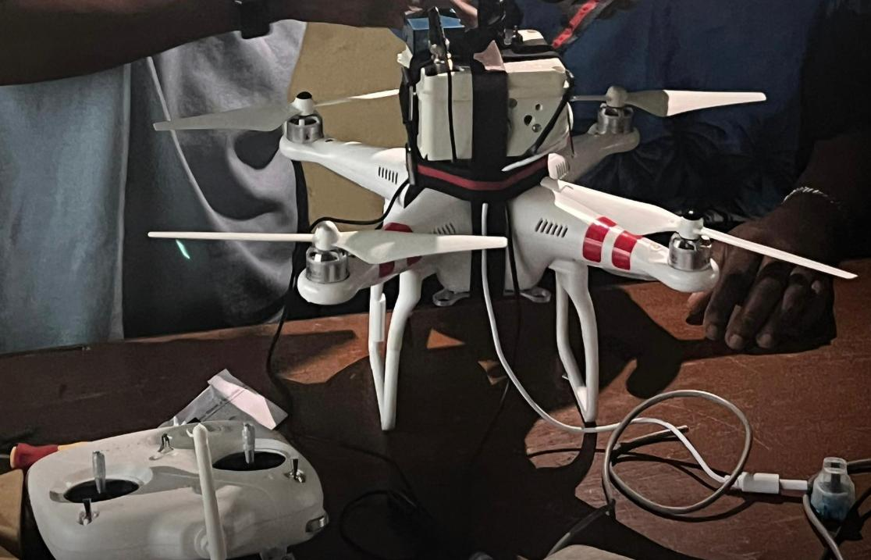
Figure 3.1: Preparation of UAV for Deployment

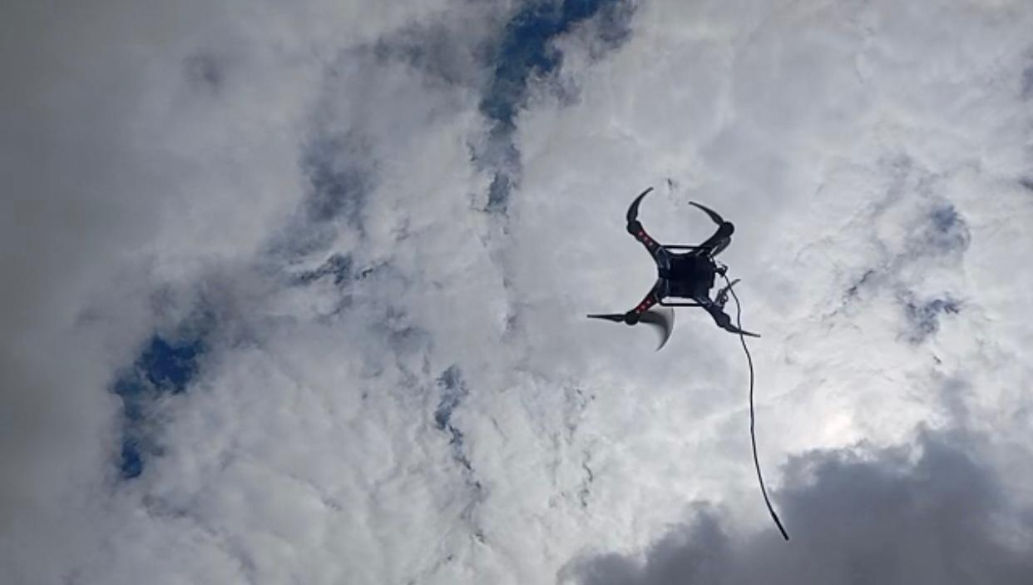
Figure 3.2: UAV in Deployment Mode Taking Atmospherically Data.
3.4 Analytical Techniques
The raw data were sorted and processed using python programming language with Pandas, NumPy, seaborn, MATLAB and sci-kit libraries to ensure uniformity, reliability and visualization. The following steps was applied:
The first stage involved data checks, where the dataset was examined for null or missing entries, which were removed to prevent computational bias. Additionally, duplicate records were identified and eliminated, and data types were standardized to maintain uniformity across computational operations. Since the altitude readings were initially recorded in meters, they were converted into kilometers to match the standard units used in some secondary radio-climatic parameters.
Once the preprocessing was completed, the secondary radio-climatic parameters were computed sequentially. The water vapor pressure was first derived from humidity and atmospheric pressure using Equation (2.1). This value was then substituted into the modified Smith-Weintraub equation (Equation 2.5) to calculate the radio refractivity (N) at each altitude level. Subsequently, the refractive index was obtained using Equation (2.6).
To quantify vertical variation, the refractivity gradient (dN/dh) was evaluated using Equation (2.7), providing insight into the rate of change of refractivity with respect to altitude. Finally, the Geo-Climatic Factor (ΔN) was computed using Equation (2.8) to assess long-term propagation reliability over the study region. Each of these computed parameters was later visualized using Seaborn and MATLAB to reveal vertical and time-dependent variations.

Table 3.1: Computed table for General Analysis
S/N | Day | Time | Altitude (m) | Temperature (C) | Humidity % | Pressure | Altitude (km) | Saturated vapor pressure | Absolute vapor pressure | N | Refractivity gradient | Geoclimatic factor
1 | Day 1 | 6am | 0 | 31.76 | 65.68 | 971.62 | 0.000 | 46.95 | 30.84 | 367.8 | -78 | 0.000106
2 | Day 1 | 6am | 25 | 31.60 | 65.48 | 968.74 | 0.025 | 46.52 | 30.46 | 365.8 | -80.0 | 0.000108
3 | Day 1 | 6am | 50 | 31.44 | 65.30 | 965.88 | 0.050 | 46.09 | 30.09 | 363.9 | -76.0 | 0.000105
4 | Day 1 | 6am | 75 | 31.28 | 65.09 | 963.02 | 0.075 | 45.68 | 29.73 | 362.0 | -76.0 | 0.000107
5 | Day 1 | 9am | 0 | 36.38 | 63.27 | 969.78 | 0.000 | 60.77 | 38.45 | 389.3 | -364.0 | 0.000717
... | ... | ... | ... | ... | ... | ... | ... | ... | ... | ... | ... | ...
716 | Day 30 | 9pm | 0 | 26.00 | 72.00 | 969.68 | 0.000 | 33.62 | 24.19 | 351.8 | -68.0 | 0.000099
717 | Day 30 | 9pm | 25 | 25.84 | 71.60 | 966.83 | 0.025 | 33.23 | 23.82 | 347.7 | -68.0 | 0.000099
718 | Day 30 | 9pm | 50 | 25.68 | 71.60 | 963.95 | 0.050 | 32.98 | 23.61 | 346.0 | -68.0 | 0.000099

Table 3.2: Pivoted Table for Analysis of Refractivity Gradient
S/N | Day | Time | N at ground surface | N at 25 m | N at 50 m | N at 75 m | Gradient at (25-0) m | Gradient at (50-0) m | Gradient at (75-0) m | Gradient at (50_25) m | Gradient at (75-50) m
1 | Day 1 | 12pm | 378.4 | 376.4 | 374.3 | 372.3 | -80.0 | -82.0 | -81.33 | -84.0 | -80.0
2 | Day 1 | 3pm | 367.6 | 365.6 | 363.7 | 361.8 | -80.0 | -78.0 | -77.33 | -76.0 | -76.0
3 | Day 1 | 6am | 367.8 | 365.8 | 363.9 | 362.0 | -80.0 | -78.0 | -77.33 | -76.0 | -76.0
4 | Day 1 | 6pm | 377.5 | 375.5 | 373.4 | 371.3 | -80.0 | -82.0 | -82.67 | -84.0 | -84.0
5 | Day 1 | 9am | 389.3 | 387.1 | 384.9 | 382.7 | -88.0 | -88.0 | -88.00 | -88.0 | -88.0
… | … | … | … | … | … | … | … | … | … | … | …
176 | Day 9 | 3pm | 358.7 | 356.8 | 354.9 | 353.0 | -76.0 | -76.0 | -76.00 | -76.0 | -76.0
177 | Day 9 | 6am | 345.6 | 343.9 | 342.3 | 340.6 | -68.0 | -66.0 | -66.67 | -64.0 | -68.0
178 | Day 9 | 6pm | 377.5 | 375.5 | 373.4 | 371.3 | -80.0 | -82.0 | -82.67 | -84.0 | -84.0
179 | Day 9 | 9am | 347.9 | 346.2 | 344.5 | 342.9 | -68.0 | -68.0 | -66.67 | -68.0 | -64.0
180 | Day 9 | 9pm | 368.8 | 366.9 | 365.0 | 363.1 | -76.0 | -76.0 | -76.00 | -76.0 | -76.0

3.5 Analysis
This analysis focused on identifying both time series and vertical variations of radio refractivity and its derived parameters:
- Time Series Analysis: Atmospheric data collected at six synoptic hours (06:00, 09:00, 12:00, 15:00, and 18:00) over a 30-day period were analyzed to reveal diurnal variations and short-term fluctuations. This approach provided a clear temporal footprint of how refractivity and related parameters evolve throughout the day.
- Vertical Profile Analysis: Data collected at different altitude levels (surface, 25m, 50m, and 75m) were used to compute refractivity gradients and altitude-dependent propagation factors. This helped identify how changes in the lower atmosphere influence signal bending, coverage, and horizon extension.
- Short scale Trend Analysis: Employing linear regression and moving averages, long-term trends and gradual shifts in atmospheric structure and refractivity gradients are identified. This is vital for assessing whether changes are consistent over time or influenced by external climatic forces.
By integrating these methods, the analysis ensured that both regular atmospheric behavior and irregular disturbances were captured, offering a comprehensive basis for understanding radio-climatic conditions over the study region.
3.6 Evaluation and Performance Metrics
To ensure the reliability and validity of the results obtained from the analysis of radio-climatic parameters, systematic evaluation was employed. These includes: Graphical techniques such as time series plots and vertical profile charts were employed as qualitative evaluation metrics. These visualizations provided intuitive confirmation of trends, anomalies, and correlations, complementing statistical assessments.

CHAPTER FOUR
RESULTS AND DISCUSSION
4.1 Introduction
This chapter presents the results obtained from the analysis of UAV-based atmospheric data collected at four altitude levels (surface, 25 m, 50 m, and 75 m) and six synoptic hours (6am, 9am, 12pm, 3pm, and 6pm) across a 30-day observation period. The results are discussed in relation to the diurnal and vertical variations of secondary radio-climatic parameters, highlighting their implications for electromagnetic wave propagation.
4.2 Radio Refractivity Variation with Altitude
Figure 4.1 illustrates the variation of radio refractivity with altitude at different times of the day. A general decreasing trend of refractivity with increasing altitude is observed across all time intervals (the lower the altitude, the higher the radio-refractivity and the higher the altitude, the lower the radio-refractivity). This behavior aligns with the well-established understanding that refractivity reduces with height due to the decline in atmospheric pressure, temperature, and water vapor concentration.
- Decreasing Refractivity (Negative Gradient): This is the normal condition in the atmosphere which causes radio waves to bend slightly toward the Earth, extending range. If the gradient is strongly negative (e.g., < –157 N/km), it leads to super-refraction or ducting, where signals can travel much farther than line-of-sight which is good for long-distance links. However, extreme cases may cause fading or multipath.
- Increasing Refractivity (Positive Gradient): Very rare, usually due to inverted temperature or humidity layers. Causes sub-refraction, where waves bend away from Earth. Degrades coverage by reducing effective range and can lead to signal loss or shadow zones.
4.3 Diurnal Variation of Radio Refractivity
Diurnal Variation of Radio Refractivity refers to the systematic changes in atmospheric radio refractivity that occur within a 24-hour period, mainly influenced by the daily cycle of solar heating and cooling. It reflects how temperature, pressure, and humidity vary between daytime and nighttime, which in turn alters the refractive index of the atmosphere and affects radio wave propagation (Adeyemi & Emmanuel, 2021).
Figure 4.2 shows that a clear diurnal cycle is also evident. The lowest refractivity values are recorded at 9:00 a.m., which may be attributed to strong solar heating after sunrise, leading to atmospheric instability and reduced surface humidity. In contrast, higher refractivity values at 6:00 p.m. and 9:00 p.m. suggest enhanced moisture retention and radiative cooling in the lower atmosphere after sunset. Midday hours (12:00 p.m. and 3:00 p.m.) show intermediate refractivity, consistent with mixing effects from convective turbulence.
These results are in agreement with previous studies in tropical regions. For instance, Falodun and Ajewole (2006), reported similar diurnal variations over Akure, Nigeria, with refractivity minima around mid-morning and maxima during late evening. Likewise, ITU-R P.453-13 indicates that surface refractivity is strongly modulated by daily cycles of temperature and humidity, particularly in humid tropical climates. The observed altitude-dependent decrease also corroborates the findings of Bean and Dutton (1968), who noted that refractivity falls off exponentially with altitude due to the vertical distribution of atmospheric constituents.
Therefore, the present analysis not only confirms established theoretical expectations but also contextualizes the dynamic refractivity behavior over the study region (FUTA, Akure). The results have practical implications for radio communication, as diurnal and altitude-dependent variations directly affect line-of-sight signal propagation, ducting conditions, and overall link reliability.
4.4 Daily Variation of Radio Refractivity
The daily variation of radio-refractivity describes how atmospheric refractivity changes throughout the day due to fluctuations in temperature, humidity, and pressure within the lower atmosphere. Figure 4.3 shows the analysis of the 30 days dataset which reveals a consistent vertical structure. Refractivity decreases steadily with altitude across all days, with surface values (0 m) always higher than those at 25 m, 50 m, and 75 m. Although the vertical separation between levels is relatively small, typically within 2 to 5 N-units, it demonstrates a stable lapse rate of refractivity with height, indicating well stratified atmospheric layers.
Day-to-day variation is quite noticeable, with refractivity values ranging from about 340 N-units at higher altitudes during dry or stable periods (e.g., Day 21 at 75 m) to around 376 N-units during moist or highly humid conditions (e.g., Days 1 and 10 at the surface). Noticeable peaks occur on Days 1, 10, 14, and 24, while troughs are evident around Days 7, 16, and 21. These oscillations likely reflect changes in regional synoptic weather conditions, including rainfall events, humidity surges, and wind-driven transport of moist or dry air masses. Rather than exhibiting a linear increasing or decreasing trend over the month, refractivity alternates in 3to 5 days cycles, suggesting an influence from transient weather systems or periodic moisture transport mechanisms. The magnitude of variability is more noticeable near the surface due to stronger fluctuations in pressure and humidity, while higher altitudes such as 75 m exhibit smoother, dampened variations. This behavior aligns with established models such as ITU-R P.453, which predict exponential decreases in pressure and humidity with altitude. Similar observations have been reported in earlier West African refractivity studies (e.g., Adediji & Ajewole, 2008), where strong short-term oscillations are linked to convective activity and moisture recycling. The results from the UAV-based measurements used in this study support these findings but provide improved resolution within the lower 100 meters of the atmosphere, a range that is often under-sampled in conventional radiosonde datasets.
From a propagation standpoint as shown in Figure 4.3 and Table 4.1, high refractivity peaks, such as those seen on Days 1, 10, and 24 indicate increased likelihood of super-refraction or ducting, which can extend radio coverage but may also introduce co-channel interference under certain broadcasting or communication setups. However, low refractivity periods, such as Days 7, 16, and 21, are associated with sub-refractive conditions, which reduce the effective radio horizon and can weaken microwave or line-of-sight communication links. The relatively small refractivity difference between 0 m and 75 m further suggests that ducting or anomalous propagation layers, when they form, are likely to occur close to the ground. This has practical implications for terrestrial communication system design, particularly for low-tower installations, point-to-point microwave links, and UAV-based relay platforms operating near the surface.

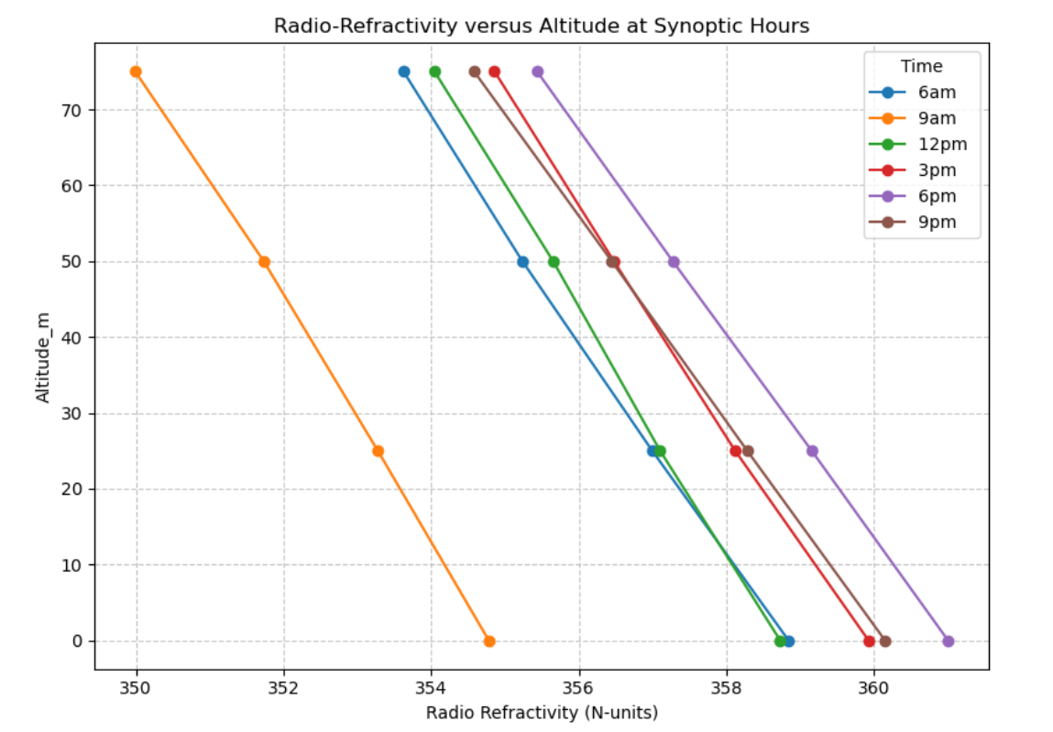
Figure 4.1: Radio-Refractivity Variation with Altitude

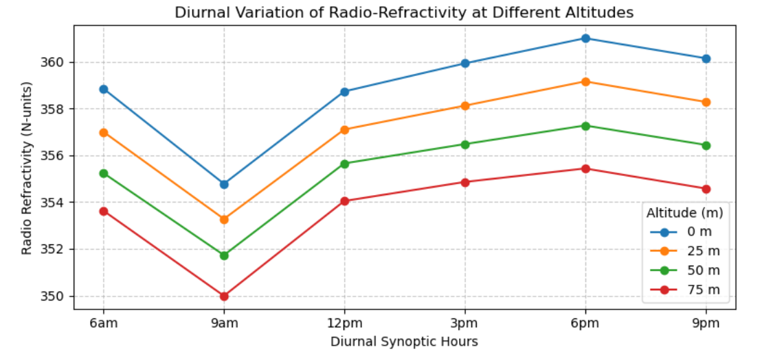
Figure 4.2: Diurnal Variation of Radio-Refractivity

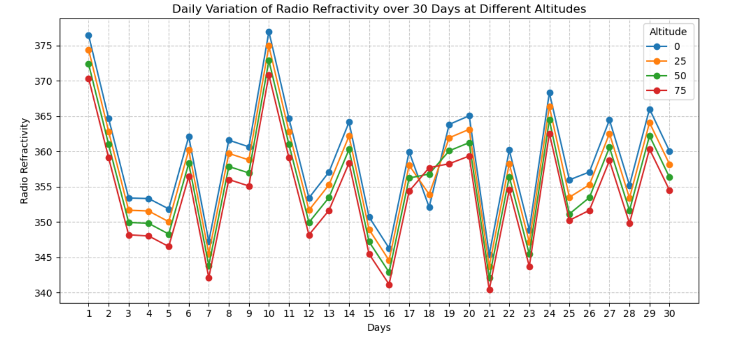
Figure 4.3: Daily Variation of Radio-refractivity

Table 4.1: Radio Refractivity Ranges and Propagation Effects. ITU-R. (2019).
Refractivity (N) | Propagation Type | Environment Example | Effect on Radio Waves
< 280 | Low Refractivity | Dry desert, high altitudes | High attenuation, reduced range
280 – 320 | Normal Propagation | Mid-latitude, temperate zones | Standard line-of-sight with mild atmospheric bend
320 – 360 | Super-refraction Likely | Humid inland or tropical regions | Signal bends more, extended coverage possible
> 360 | Ducting / Trapping | Coastal, marine, moist air layers | Signals travel long distances, possible interference

4.5 Variation of Refractivity Gradient
The refractivity gradient is a key factor in determining how radio waves bend in the atmosphere. It measures how fast refractivity (N) changes with height. If refractive gradient (dN/dh) is negative, refractivity decreases with height (common in the troposphere). If refractive gradient (dN/dh) is positive, refractivity increases (rare but possible in some conditions). A large negative gradient can lead to ducting, causing radio waves to be trapped and travel long distances.
The refractivity gradient values are mostly negative, which is expected since refractivity decreases with altitude. This indicates a normal propagation condition where radio waves bend slightly toward the Earth’s surface.
4.5.1 Variation of Surface-Reference Refractivity Gradient with Synoptic Hours
In Figure 4.4(a), the surface-referenced refractivity gradient (25–0 m, 50–0 m, and 75–0 m) shows a clear diurnal cycle. At 6 a.m., gradients are steep (around –70 to –74 N-units/km), reflecting strong nocturnal cooling and stable stratification near the surface. This stability weakens after sunrise, and by 9 a.m., the gradients become less negative (–60 to –64 N-units/km), indicating enhanced vertical mixing due to solar heating. Around 12 p.m., values remain relatively weak (close to –62 N-units/km), before gradually steepening again toward the evening (–71 to –75 N-units/km at 6–9 p.m.).
This pattern suggests that daytime turbulence reduces refractivity gradients, while nighttime radiative cooling strengthens them. Such behavior is consistent with Oyewole et al. (2025), who observed weaker refractivity gradients during midday in West African environments, and Usman et al. (2024), who highlighted the role of solar-driven convection in reducing gradient magnitude. Similarly, Fashade et al. (2023) linked evening steepening of gradients to boundary layer stabilization after sunset.
From a radio propagation perspective, weaker gradients (–60 N-units/km) at midday imply reduced super-refraction and a more standard propagation environment. Conversely, the stronger negative gradients at night (–74 N-units/km) increase the likelihood of anomalous conditions such as super-refraction or ducting near the surface, as also reported by ITU-R P.453-13 (2019).

4.5.2 Variation of Layer-by-Layer Refractivity Gradient with Synoptic Hours
The plot in Figure 4.4(b), shows that refractivity gradients vary with both synoptic hour and layer depth. At 6 am, gradients are relatively steep (around –74 N-units/km at 25–0 m), reflecting strong cooling near the surface and moisture accumulation overnight. By 9 am to 12 pm, gradients in all layers relax, with the shallowest layer (50–25 m) showing the least negative gradient (–58 N-units/km). This suggests that morning solar heating reduces stratification, promoting a more neutral refractivity profile.
Between 3 pm and 6 pm, the gradients steepen again, particularly at the surface (25-0 m), where values approach –73 to –75 N-units/km. This afternoon strengthening is likely tied to enhanced instability and vertical mixing, which increases moisture contrast between the ground and overlying layers. By 9 pm, all layers converge toward –74 N-units/km, reflecting a return to nocturnal stability and stronger refractive bending.
A key feature of this plot is the vertical differentiation of gradients. The shallow layer (25–0 m) exhibits stronger variability across synoptic hours, while the 75–50 m layer remains relatively stable. This indicates that diurnal forcing (solar heating and surface cooling) exerts its strongest influence closest to the ground, while upper layers respond more moderately.
As shown in table 4.2, The presence of strong negative gradients (more negative than –40 N-units/km) across all layers suggests conditions favorable for super-refraction and potential ducting, especially during early morning (6 am) and evening (6–9 pm). This agrees with ITU-R P.453-13 (2019) recommendations that surface-based refractivity gradients are the primary driver of anomalous propagation in the lower troposphere. Afternoon weakening of the gradient reduces ducting potential, improving normal line-of-sight (LOS) propagation.
In summary, the diurnal cycle of refractivity gradients in this study aligns with previous findings, confirming that early morning and evening conditions are more prone to abnormal propagation, while midday conditions approximate standard propagation environments.

4.5.3 Combined Refractivity Gradient (Surface-Referenced Versus Layer-by-Layer)
When comparing the surface-referenced gradients (25–0, 50–0, 75–0 m) with the layer-by-layer gradients (25–0, 50–25, 75–50 m), in Figure 4.4 (c). Two key differences were observed:
  - Strength of Gradients
The surface-referenced gradients show generally more negative values (–60 to –74 N-units/km), particularly at lower altitudes.
The layer-by-layer gradients are less steep above the first 25 m (e.g., 50–25 m and 75–50 m), with fluctuations that are smoother and closer to –60 N-units/km around noon.
This shows that including the surface in the reference (0 m) amplifies the refractivity gradient because of strong surface cooling/heating and moisture contrasts.
  - Diurnal Sensitivity
In the surface-referenced plot, the 25–0 m gradient exhibits sharp diurnal swings, with the strongest steepening in early morning (6 am) and late evening (6–9 pm).
In the layer-by-layer plot, gradients above 25 m (50–25 and 75–50 m) vary less dramatically with time, suggesting that surface forcing diminishes with altitude.
This highlights the surface boundary layer as the dominant driver of diurnal refractivity variability, while higher layers are less responsive.
4.5.4 General Comparison of Refractivity Gradient and Radio Refractivity with Altitude.
The comparison between radio refractivity and refractivity gradient with altitude provides a more complete understanding of how atmospheric structure influences electromagnetic wave propagation. The refractivity with altitude plot in Figure 4.1 shows a steady and almost linear decrease in refractivity from the surface up to 75 m, indicating that radio refractivity generally weakens with height due to decreasing air pressure and moisture content. However, the refractivity gradient plots in Figure 4.4 (c) Shows both surface-referenced and layer-by-layer which reveal that although refractivity decreases uniformly with altitude, the rate at which it decreases is neither constant nor uniform across different layers or times of day. This distinction is crucial, as refractivity describes the mean structure of the atmosphere, while the gradient identifies where and when propagation anomalies are most likely to occur.
Near the surface (0-25 m), the refractivity gradient is steepest, with large negative values often exceeding –70 N-units/km. This supports the refractivity-altitude observation that the most rapid decline in refractivity occurs close to the ground, where humidity and temperature fluctuate more strongly due to surface heating and evaporation. At higher layers (50–75 m), both refractivity and gradient values stabilize, suggesting a more uniform and less turbulent environment. This means that the surface layer is the most sensitive zone for refractive disturbances, and thus the most critical for terrestrial radio systems operating at low antenna heights.
Temporal variation also plays a key role. While the refractivity-altitude profile presents a static vertical view, the gradient plots figure 4.4(c) clearly demonstrate diurnal dependence. Steeper gradients are observed during early morning and late evening, when temperature inversions and moisture accumulation enhance refractive bending. Around midday, gradients become flatter due to atmospheric mixing from solar heating. This shows that refractivity alone cannot explain short-term propagation effects; only gradient analysis captures the dynamic evolution of the boundary layer across the day.
Overall, refractivity values describe the baseline atmospheric structure, while refractivity gradients identify the layers and hours where radio signals are most affected, either through super-refraction, sub-refraction, or ducting. This combined interpretation is consistent with Willoughby et al. (2017), who emphasized that refractivity profiles set the background state, but only gradient variations explain anomalous propagation events. Oyedun et al. (1994) also noted that while refractivity declines steadily with height, gradients fluctuate with time, making them more relevant for short-term communication reliability. Similarly, ITU-R P.453-13 (2019) recommends multi-layer refractivity gradient assessment rather than relying solely on refractivity values for accurate prediction of radio horizon extensions. Therefore, integrating both parameters offers a more realistic framework for designing and optimizing radio communication systems, particularly in tropical climates where surface-based refractive disturbances are common.

4.6 Variation of Geo-Climatic Factor with Altitude
The geoclimatic factor K is a site-dependent parameter used in radio wave propagation studies, especially for estimating Signal Fading and Multipath Propagation as shown in table 4.3.
- Low K (<0.01) → Low multipath fading probability, stable link.
- Moderate K (0.01–0.05) → Seasonal multipath fading, some caution for high-reliability links.
- High K (>0.05) → High multipath probability, common in humid, coastal, or tropical climates.
Figure 4.5 shows that the geo-climatic factor decreases steadily with altitude at all synoptic hours, with higher values concentrated near the surface (0–25 m) and tapering off beyond 50 m. This indicates that surface-layer atmospheric variability plays the most significant role in shaping geo-climatic effects, while higher altitudes contribute less.
The geo-climatic factor also shows higher values near the surface during midday hours (12 pm and 3 pm), while early morning (6 am) and evening (6 pm, 9 pm) remain relatively stable with lower values. This diurnal pattern reflects the strong influence of solar heating on surface-layer refractivity, which amplifies variability in the geo-climatic factor. With increasing altitude (above 50 m), the variations flatten out, suggesting that time-of-day effects are mostly confined to the lower atmosphere.
This observation agrees with Adediji et al. (2011), who reported that diurnal heating significantly modulates geo-climatic factors in tropical regions, and with ITU-R P.452-16 (2015), which stresses that accurate propagation models must capture both vertical and temporal variability to improve radio link reliability.
In essence, the combined effect of altitude and time highlights that midday and near-surface conditions contribute most strongly to geo-climatic variability, making them critical for radio link planning in Akure.

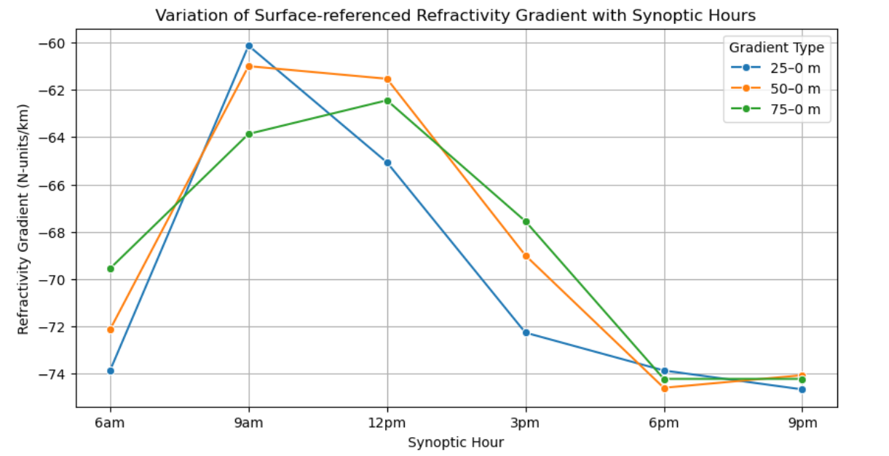
Figure 4.4(a): Variation of Surface-Referenced Refractivity Gradient with Synoptic Hours

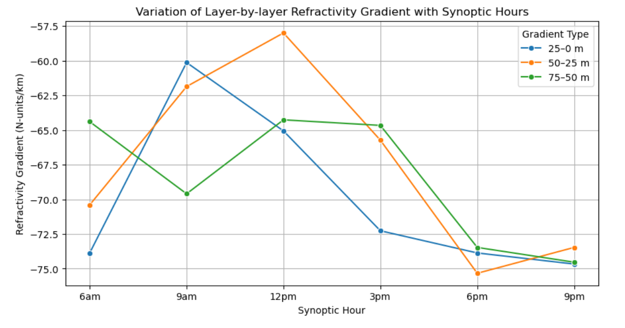
Figure 4.4(b): Variation of Layer-by-Layer Refractivity Gradient with Synoptic Hours
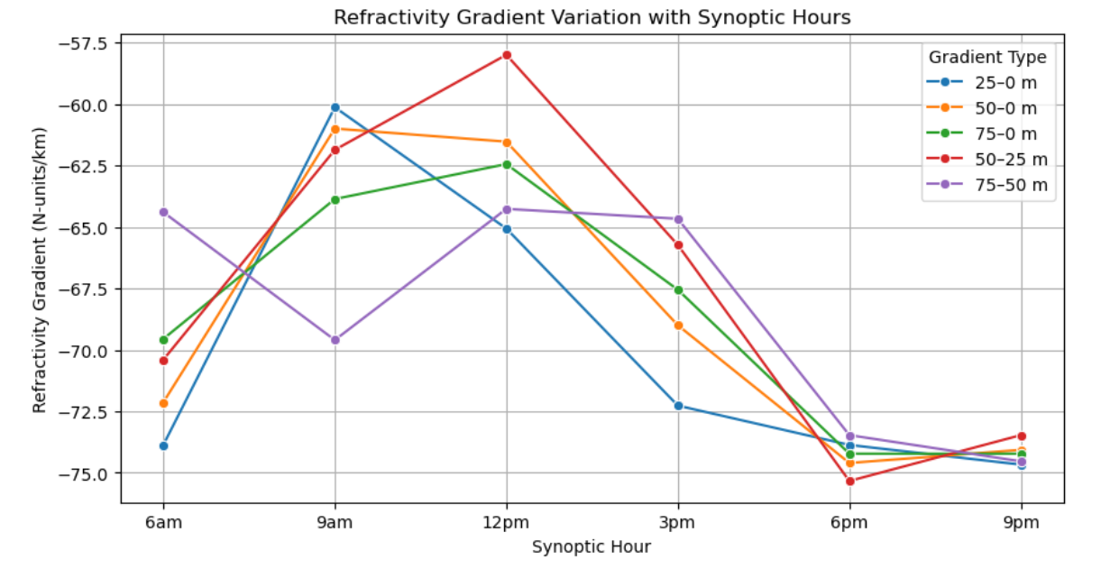
Figure 4.4 (c): Combined Refractivity Gradient (Surface-Referenced Versus Layer-by-Layer)

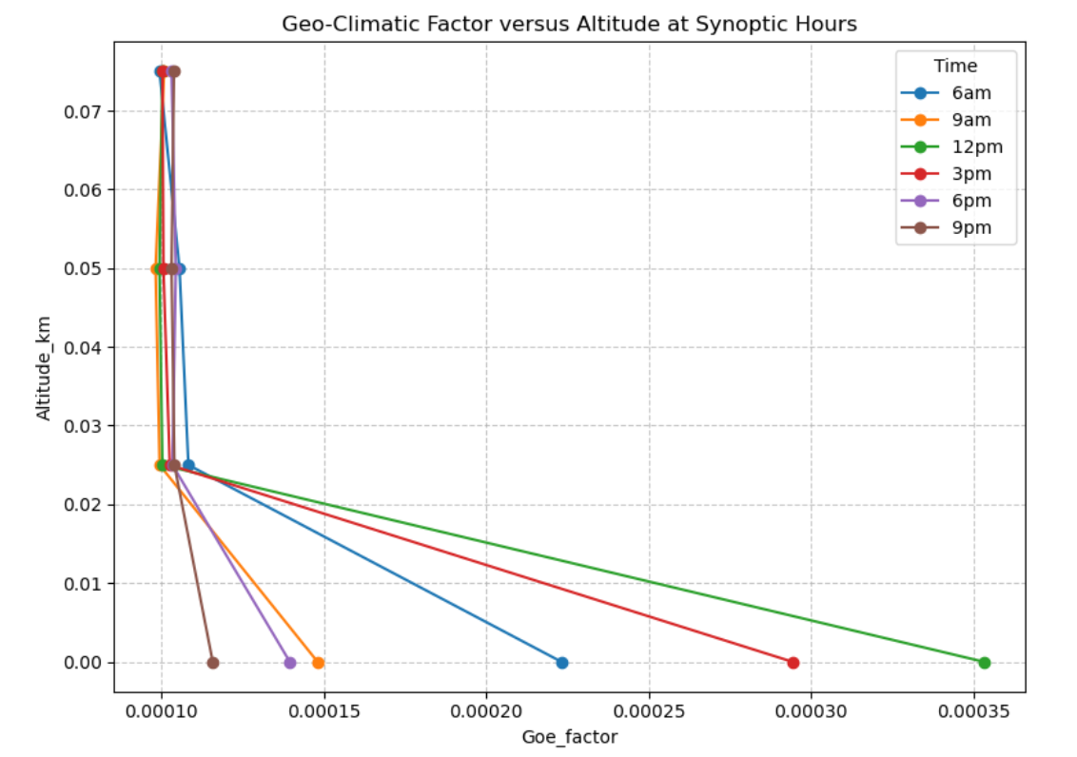
Figure 4.5: Variation of Geo-Climatic Factor with Altitude

Table 4.2: Refractivity Gradient Ranges and Interpretation. ITU-R. (2019)
Atmospheric Condition | Refractivity Gradient | Effect on Radio Waves
Standard Atmosphere | –40 N/km | Normal refraction
Sub-refraction | > –40 N/km | Waves bend less, reduced coverage
Super-refraction | < –40 N/km | Waves bend more, extended coverage
Ducting (extreme super-refraction) | < –157 N/km | Waves trapped near surface, long range

Table 4.3: Geo-climatic Factor Ranges and Interpretation. ITU-R. (2019)
Multipath Fading Category | Geoclimatic Factor (K) Range | Interpretation
Low Multipath Fading | 0.00001 – 0.00005 | Minimal signal degradation; stable atmospheric conditions
Moderate Multipath Fading | 0.00005 –0.00015 | Noticeable fading; typical in temperate zones or transitional seasons
High Multipath Fading | >0.00015 | Severe fading; common in tropical, coastal, environments

CHAPTER FIVE
CONCLUSION AND RECOMMENDATION
5.1 Conclusion
This study investigated the vertical variation of radio refractivity and some secondary radio-climatic parameters (refractivity gradient, k-factor, and geo-climatic factor) at four altitude levels (0 m, 25 m, 50 m, and 75 m) using drone-based measurements over a 30-day period in Akure, Nigeria.
The major findings are summarized as follows:
- radio Refractivity decreased with increasing altitude, with the highest values observed at the surface (0 m) and the lowest values at 75 m. This behavior is attributed to decreasing humidity and temperature influence with height.
- refractivity Gradient showed predominantly negative values across the vertical profile, indicating the presence of super-refraction and potential ducting conditions that can significantly influence signal propagation near the surface.
- k-Factor deviated from the standard 1.33 value, remaining closer to unity, suggesting that the assumption of a fixed k-factor may not be valid for this region and that local measurements are essential for accurate link design.
- geo-Climatic Factor was highest at the surface and gradually reduced with altitude, implying that ground-level atmospheric variability exerts a stronger influence on radio wave propagation than higher levels.
Overall, the results confirm that vertical variation plays a crucial role in determining propagation conditions in the lower atmosphere. Reliable communication system design in Akure and similar tropical environments should therefore account for these variations rather than relying on generalized global models.

5.2 Recommendations
Based on the findings of this research, the following recommendations are made:
- extended Vertical Profiling: Future studies should extend measurements beyond 75 m, ideally up to several hundred meters, to fully capture the vertical distribution of refractivity and related parameters.
- long-Term Monitoring: Observations covering multiple seasons or an entire year should be conducted to capture seasonal variations in the vertical structure of refractivity.
- integration into Propagation Models: Communication engineers and network planners should incorporate locally measured vertical refractivity profiles into link budget and coverage models, particularly for microwave and satellite systems.
- consideration of Anomalous Propagation: Since super-refraction and ducting were evident in the results, these phenomena should be explicitly included in link design for improved system reliability.
- policy Support: Regulatory agencies (e.g., the Nigerian Communications Commission) should encourage localized radio-climatic studies to provide reliable datasets for frequency management and network planning.

REFERENCES
Abimbola, O. J., Bada, E., Falaiye, A. O., Sukam, Y. M., & Muhammad, S. (2020). Estimation of radio refractivity from a decade of satellite-derived meteorological data for West Africa.
Adediji, A. T., & Ajewole, M. O. (2008). Vertical profile of radio refractivity gradient in Akure South-West Nigeria. Progress in Electromagnetics Research C, 4, 157–168.
Adeyemi, B., & Emmanuel, I. (2021). Diurnal and seasonal variability of atmospheric radio refractivity over Nigeria: Implications for radio wave propagation. Atmospheric Research, 249, 105309.
Aliyu, M. A., Akpootu, D. O., Aminu, Z., Aruna, S., Agidi, O. E., Salifu, S. I., Idris, M. (2021). Investigation of tropospheric radio refractivity and other relevant parameters using meteorological variables over Bauchi, Nigeria. FUDMA Journal of Sciences, 8(2), 306-314.
Bean, B. R., & Dutton, E. J. (1968). Radio Meteorology. Dover Publications.
Buck, A. L. (1981). New equations for computing vapor pressure. Journal of Applied Meteorology, 20(12), 1527–1532.
Kaissassou, S., Djiotang, L., Komkoua, A., Ekobo, B., Ndzana, B., Tanessong, R., Guenang, M., & Vondou, A. (2021). Climatology of super-refraction and trapping layers conditions over Central and West Africa. Meteorological Applications, 28(4), e2016.
De Boer, G., Argrow, B., Cassano, J., Cione, J., Frew, E., Lawrence, D. (2016).
Unmanned Aircraft Systems for Atmospheric Research: Current Capabilities and Future Outlooks. Bulletin of the American Meteorological Society, 97(5), 873–890.
Elston, J. S., Argrow, B., Stachura, M., Weibel, D., Lawrence, D., & Pope, D. (2015). Overview of small fixed-wing unmanned aircraft for meteorological sampling. Journal of Atmospheric and Oceanic Technology, 32(1), 97-115.
Falodun, S. E., & Ajewole, M. O. (2006). Radio refractive index in the lowest 100-m layer of the troposphere in Akure, South-Western Nigeria. Journal of Atmospheric and Solar-Terrestrial Physics, 68(2), 236-243.
Fashade, O. O., Akinwumi, S. A., Omotosho, T. V., Arijaje, T. E., Ayo-Akanbi, O. A., Ogundolie, O. I., Ometan, O. O., & Adewusi, O. M. (2023). Evaluation of refractivity gradient and k-factor within the lower troposphere of Maiduguri and Enugu under two climatic zones in Nigeria. International Journal on Applied Physics & Engineering, 2(1), 1–6.
Frew, E. W., & Brown, T. X. (2008). Airborne communication networks for small unmanned aircraft systems. Proceedings of the IEEE, 96(12)
Girdwood, J., Price, H. C., Stopford, C., Al-Qadi, N., Reed, C., & Pope, F. D. (2020). Design and field campaign validation of a multi-rotor UAV and optical particle counter. Atmospheric Measurement Techniques, 13(3), 1501–1516.
Hall, M., & Barclay, L. W. (2012). Propagation of Radio waves (2nd ed.). Institution of Engineering and Technology.
Holton, J. R., & Hakim, G. J. (2012). An Introduction to Dynamic Meteorology (5th ed.). Academic Press
Houston, A. L., Argrow, B., Elston, J., Lahowetz, J., Frew, E. W., & Kennedy, P. C. (2012). The Collaborative Colorado–Nebraska Unmanned Aircraft System Experiment. Bulletin of the American Meteorological Society, 93, 39-54
International Telecommunication Union, Radiocommunication Sector (ITU-R). (2019). The radio refractive index: its formula and refractivity data (Recommendation ITU-R P.453-14). ITU.
Lawal, Y. B., & Omotoso, E. T. (2023). Investigation of Point Refractivity Gradient and Geoclimatic Factor at 70 m Altitude in Yenagoa, Nigeria. Journal of the Nigerian Society of Physical Sciences, 5(1), Article 1081.
Layioye, O. (2024). Tropospheric variation of point refractivity gradient and geo-climatic factor for Ikeja, Lagos.
Lewis, O., Brunt, C., & Kitchen, M. (2023). A new method of retrieving atmospheric refractivity structure. International Journal of Remote Sensing, 44(?, ?), 749-785.
Li, X., Wang, Y., & Chen, Z. (2019). Retrieval of tropospheric refractivity profiles using slant tropospheric delays derived from a single ground-based GNSS station. Earth and Space Science, 6, 1081-1097.Ogunjo, S. T., & Adesiji, A. T. (2020). refractivity gradient / propagation study over Nigeria.
Owolabi, I. E., Adeyemi, B., & Ogunjo, S. T. (2021). Atmospheric refractivity variability and its impact on microwave link performance. Journal of Atmospheric and Solar-Terrestrial Physics, 223, 105729.Oyedum, O. D., & Gambo, T. S. (1994). Variations of surface radio refractivity and refractivity gradients in Nigeria. Nigerian Journal of Physics, 6(1), 36–42.
Oyewole, O. J., Sirola, C., Pandit, A., & Ayo, S. (2025). The study of altitudinal refractivity and refractivity gradient variations by weather parameters in some selected locations in Nigeria. Physical Science International Journal, 29(3), 42–49.
Parsons, J. D. (2000). The Mobile Radio Propagation Channel (2nd ed.). John Wiley & Sons.
Sabiru, A. Y., Akinbolati, A., Ikechiamaka, F. N., & Abe, B. T. (2024). Characterization of some secondary radio-climatic factors for reliable radio wave propagation and link’s design over North Western Nigeria. Advances in Space Research, 74(5), 890–898.
Seidel, D. J., Sun, B., Pettey, M., & Reale, A. (2011). Global radiosonde balloon drift statistics. Journal of Geophysical Research: Atmospheres, 116, D07102.
Smith, E. K., Jr., & Weintraub, S. (1953). The constants in the equation for atmospheric refractive index at radio frequencies. Journal of Research of the National Bureau of Standards, 50(1), 39–60.
Suleman, K. O., Olawuyi, A. S., Joseph, O., Ogunmola, O. L., Alagbe, G. A., Azeez, S. O., Suleiman, S. B., Adegbaye, A. L., Ahmed, K., & Sunmonu, L. A. (2025). Investigation of Diurnal and Seasonal Variation of Radio Refractivity and Field Strength over Ogbomoso, South-Western Nigeria. In Proceedings of the 8th URSI-NG Annual Conference (URSI-NG 2024), Advances in Physics Research. Atlantis Press
Sun, Y., Yuan, H., Sato, Y., & Kuo, Y.-H. (2019). Retrieval of Tropospheric Refractivity Profiles Using Slant Tropospheric Delays Derived From a Single Ground-Based Global Navigation Satellite System Station. Earth and Space Science, 6, (2019EA000562).
Stull, R. B. (2017). Practical Meteorology: An Algebra-based Survey of Atmospheric Science (Version 1.02b). University of British Columbia. https://www.eoas.ubc.ca/books/Practical_Meteorology/index.html
Turton, J. D., Darling, R. W. R., & Gunton, R. (1988). The use of radiosonde data for the prediction of anomalous propagation conditions. Meteorological Magazine, 117, 157–168.
Usman, S. L., Ikechiamaka, F. N., Akinbolati, A., Owolabi, J. A., & Akusu, C. O. (2024). Exploring vertical gradients of radio refractivity and their significance for radio wave propagation in Abuja, Jos, and Makurdi of North-Central Nigeria. Science World Journal, 19(1), 58–63.
Wang, S., Lim, T. H., Oh, K., Seo, C., & Choo, H. (2021). Prediction of wide range two-dimensional refractivity using an IDW interpolation method. Applied Sciences, 11(4),
Willoughby, A. A., Omotoso, T. V., & Owolabi, I. E. (2017). Seasonal variations of radio refractivity gradients in Nigeria: Spatial and temporal analysis. Journal of Atmospheric and Solar-Terrestrial Physics, 194, 25-34World Meteorological Organization (WMO). (2017). Guide to Meteorological Instruments and Methods of Observation (WMO-No. 8). Geneva, Switzerland: WMO.
Zhou, Y., Liu, Y., Qiao, J., Li, J., & Zhou, C. (2022). Statistical analysis of the spatiotemporal distribution of lower atmospheric ducts over the seas adjacent to China, based on the ECMWF reanalysis dataset. Remote Sensing, 14(19), 4864.

